1. Add Fiegn Client Dependency in OrderService as we need to call

from OrderService to ProductService(reduceQuantity API)

<dependency>  
 <groupId>org.springframework.cloud</groupId>  
 <artifactId>spring-cloud-starter-openfeign</artifactId>  
</dependency>

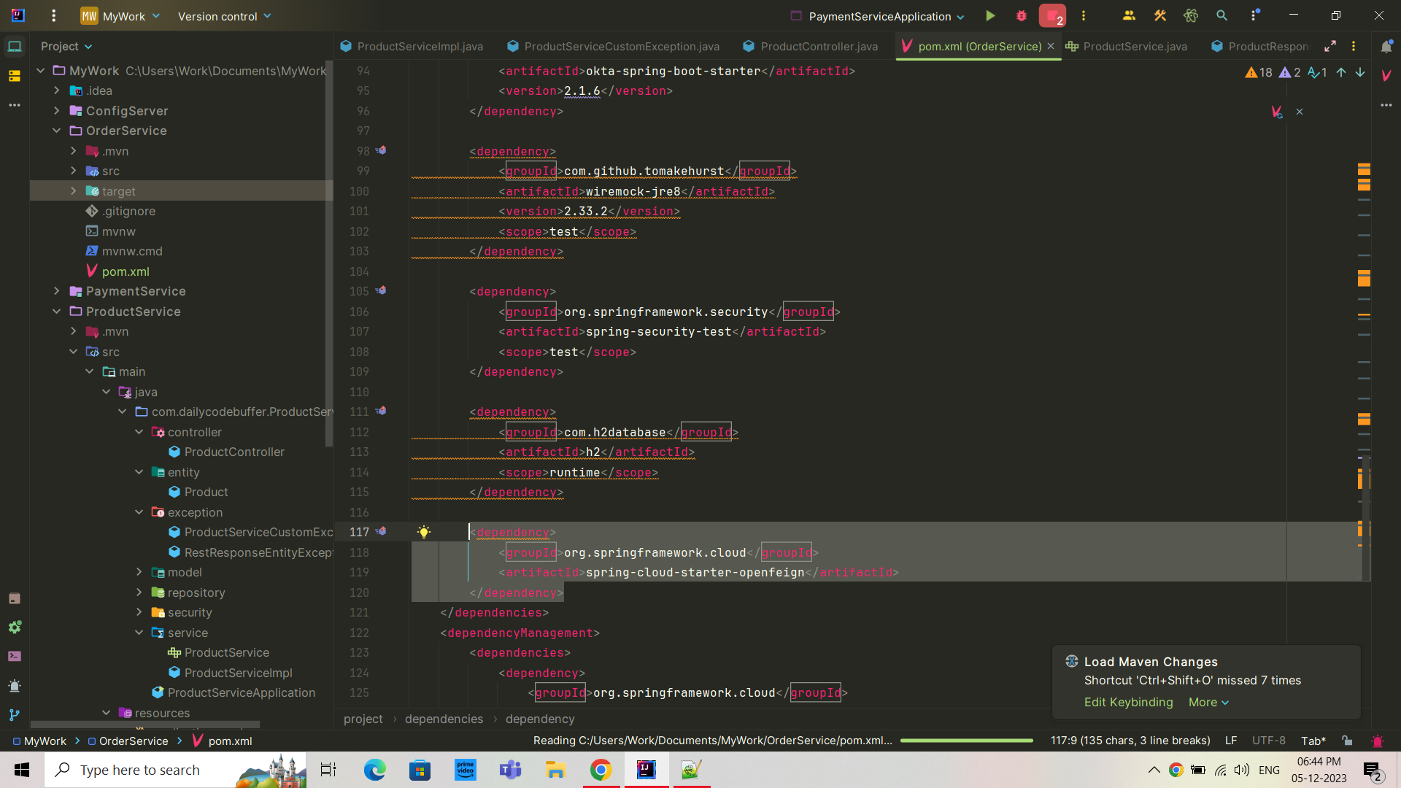

1. Add @EnableFiegnClients in Main.java
2. Create external package and client package inside that and then create ProductService.java

external.client.ProductService (Interface)

*@FeignClient*(name = "PRODUCT-SERVICE/product")  
public interface *ProductService* {  
  
 *@PutMapping*("/reduceQuantity/{id}")  
 *ResponseEntity*<*Void*> reduceQuantity(  
 *@PathVariable*("id") long *productId*,  
 *@RequestParam* long *quantity* );

1. Open OrderServiceImpl.java

*@Autowired*private *ProductService* productService;

1. In the same file we need to add one line before storing orderService:

productService.reduceQuantity(*orderRequest*.getProductId(), *orderRequest*.getQuantity());

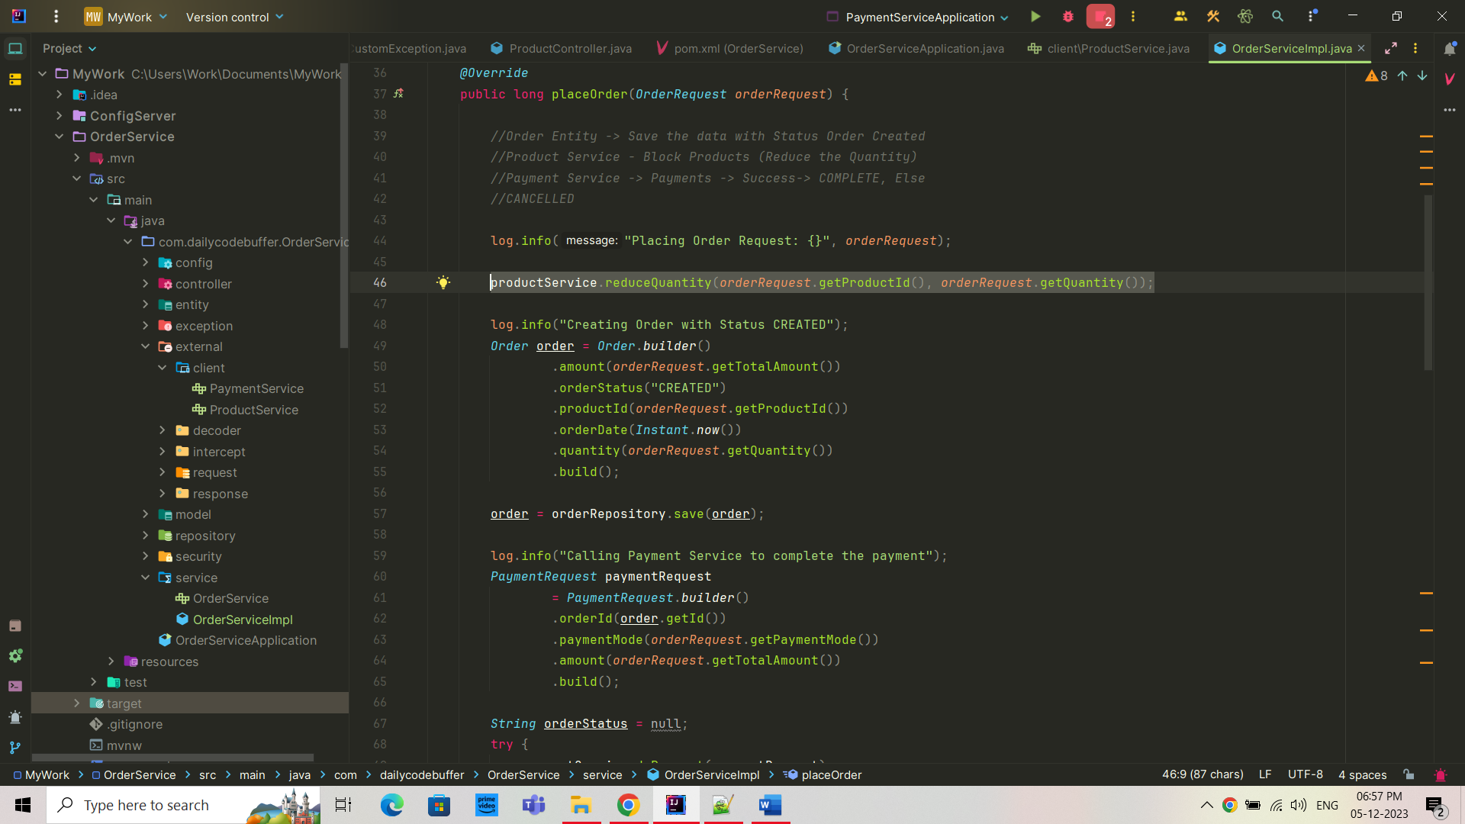

After doing this our reduceQuantity API we will be working from OrderService itself. Earlier it was only working from the productService